

**MAKING**

**PROPERTY**

**WORK**

**SHW.CO.UK**

**Rent | £67,500 pax Industrial/Warehouse Unit 04 September 2024**

**Description**

The property is an older style mid terrace unit providing a mix of open space at the front with offices/ancillary space on a raised section at the rear and benefiting from a large mezzanine that could be removed.

**location**

The property is located on the Chessington Industrial Estate, 4 miles south of Kingston, just off the A3, 1.3 miles, at Tolworth which provides fast access to the M25 (J10) 10 miles and Central London, 15 miles. The property is situated on Davis Road close to the junction with Cox lane.

## accommodation (gross internal area)

|  | SQ FT | SQ M |
| --- | --- | --- |
| Main Warehouse | 3,612 | 335.55 |
| Rear Office/Ancillary (Raised level) | 1,790 | 166.29 |
| Mezzanine Front | 869 | 80.73 |
| Mezzanine Rear | 3,672 | 341.13 |
| **TOTAL** | **9,943** | **923.70** |

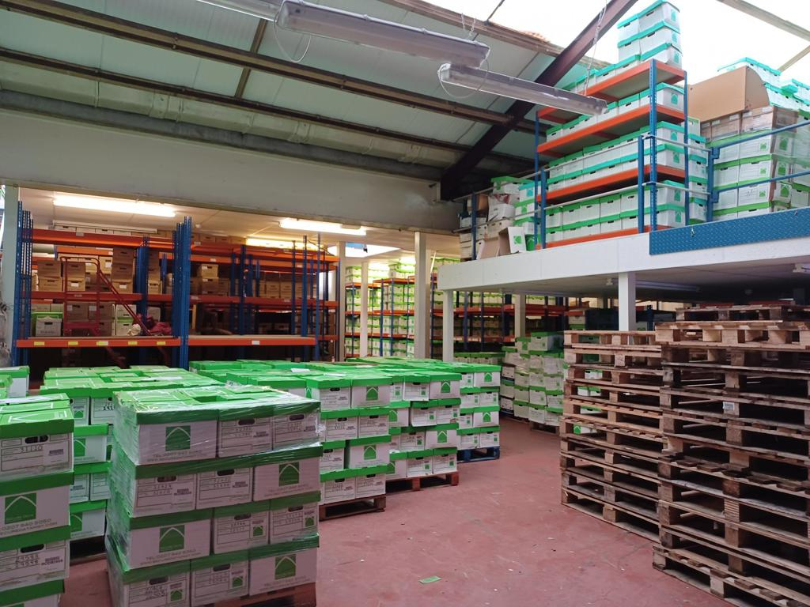

## AMENITIES

* Eaves 4.2m
* Ridge 6m
* Warm air blowers
* Loading door 4.18 x 3.13m
* 3 Phase electricity
* Forecourt parking/loading 4 cars

**rent**

£67,500 per annum exclusive.

## Tenure

Available to let on a new full repairing and insuring lease, term to be agreed.

**Rates**

TBC.

**vat**

VAT will be chargeable on the rent.

**legal costs**

Each party is to be responsible for their own legal fees.

## EPC

© OpenStreetMap contributors

The property has an EPC rating of D.

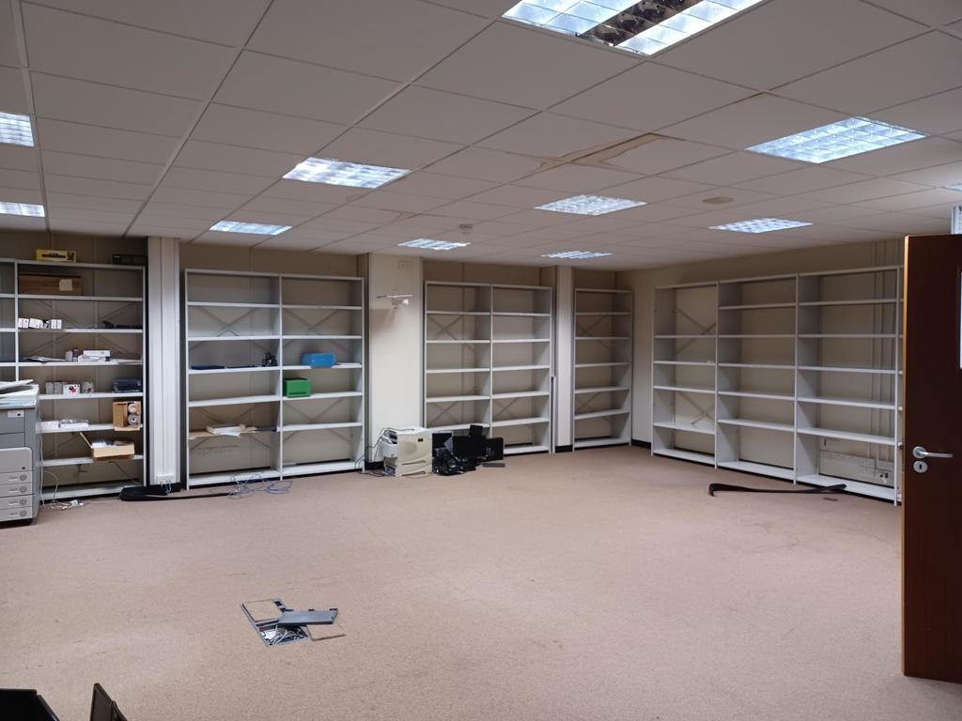

**MAKING**

**PROPERTY**

**WORK**

**SHW.CO.UK**